M.Ertürk IŞIKPINAR
İstanbul, Turkey

Complexity and Transactional Dynamics

Abstract
An analysis of a system as co-evolving and self-organizing requires a holistic approach which can deal with complexities of values, spaces and physical systems in regard to their environment. Within this totality values are the primary determiners and can be assessed through psychology.
The transactional world view in environmental psychology implies a pragmatic, eclectic and relativistic approach to psychological phenomena, in which stability / change are intrinsic and defining features of psychological phenomena, change occurs continuously, directions of change are emergent and not pre-established.
Ecological psychology developed based on these ideas is the study of interdependent relationships between goal-directed actions of each spatial component including the humans and the environment in a particular spatial and temporal context.
In the paper, possible applications of the transactional approaches in complexity thinking will be opened to discussion with emphasis on environmental psychology, ecological psychology, ecopsychology and cognitive psychology. Examples of work in spatial planning performed at applied capacity in ecological psychology will be presented.

Dr. M.Ertürk IŞIKPINAR, Urbanist-M.Arch., Planning and Design Consultant, Istanbul, TURKEY. (Former establisher of Applied Research in Environmental Psychology at the Planning Department of İllerbank, Municipalities Bank of the Turkish Ministry of Public Works)
M.Ertürk IŞIKPINAR
İstanbul, Turkey

Complexity and Transactional Dynamics

1.0 Introduction
A critical issue in spatial planning and design concerns the human factor and its position within the totality. Despite all efforts to crystallize and acquire clear-cut approaches and methodologies to the social and human aspects of spatial planning especially the past two decades have made it clear that the evaluations of the human factor in this context stay insufficient. As encountered at urban scales in almost all countries, especially the evolving and co-evolving phenomena constitute the basic ‘self-constructed’ spatial organizations stand as the primary indicators of the complexity of the situation.
The question arises from the main philosophy of approach and from methodology and techniques involved. Firstly, the approaches employed in spatial planning to have been based on behaviouristic and deterministic philosophy. The human being has a personality, has the observable qualities which can be evaluated through the approaches acquired based on this philosophy. Secondly, a main problem emerges from the necessity of obtaining data measurable and applicable. This calls for which might be termed an oversimplification of data based on materialistic and deterministic approaches. Computer aided approaches based on attempts to express the human values fail to represent the human factor involved.
2.0 Environment and Psychology
Ittelson and his colleagues stress the fact that man’s relation to the environment is quite different from before because of what can be called environmental awareness out of which a new set of attitudes and values is emerging. Man’s assessment of the environment, about space and its uses, about social processes engendered by architectural forms, the ecological message, the effects of density, the influence of cultural norms on our territorial sense, the importance of urban design, and our conceptualization of the environment as a source of identity, presents us with a new way of thinking about man, ‘environmental man’ (Ittelson, 1974). “Feeling and thinking humanity, man in his behavioural essence, has existed beneath the prevailing self-concept of every age always. More recent times is characterized by this new awareness of this essential self, the concept of identity as psychologically generic, hence ‘psychological man’” (Ittelson, 1974). “In our day, rather ironically, because of his complex interaction with his environment, man can be called ‘environmental psychological man’” (Işıkpınar, 1996).
Efforts to determine the state of the art has been going on with increasing efforts. Amongst other scholars De Young points to the encompassing nature of the field by stating that the field defines the term environment very broadly including all that is natural on the planet as well as social settings, built environments, learning environments and informational environments. He asserts that the field develops such a model of human nature while retaining a broad and inherently multidisciplinary focus. It explores such dissimilar issues as common property resource management, way finding in complex settings, the effect of environmental stress on human performance, the characteristics of restorative environments, human information processing, and the promotion of durable conservation behaviour. (De Young, 1999)
2.1 Environmental Psychology and Ecopsychology
In current practice two fields of psychology can be cited in relation to spatial planning : environmental psychology and ecopsychology. Furthering this discussion it is notable that novel fields of psychology are being formulated for the study of the physical environment. One such field is the emerging field of ecopsychology.
Jon Davis states that Environmental psychology and ecopsychology are fields dealing with the interrelations between human behaviour and environments. Whereas environmental psychology deals with the totality of the environment, with its physical and social aspects, ecopsychology is interested as its primary goal in the relationships of mental and physical well-being and the natural environment. He argues that environmental psychology is a well established academic field with a research base, focusing on the way humans interact with their environments. Ecopsychology on the other hand is an emerging orientation, draws from ecology, psychology, philosophy and other fields. He stresses that ecopsychology is based on the intimate connection between humans and nature, the implications of that connection, and applications for realizing that connection. (Davis, 200).
In environmental psychology change is a central issue, it tries to discover ‘better life’ by future oriented approaches. In ecopsychology an existing site is selected as appropriate for ‘good life’ such as the selection of the natural environments. Environmental psychology is offering approaches which can be controlled and statistically evaluated in a much more systematic context. Ecopsychology on the other hand with a wide panorama is extremely inspiring, however this inspiration gives rise to a dispersed proliferation of methodologies of application which is rather difficult to organize and control especially for the socio-cultural urban situations. (Işıkpınar, 2009 )
2.2 Planning and Psychology
Quoting from several scholars environmental psychologist Churchman analyses the approaches of the psychologist against those of the planners. Firstly, she asserts that the parameters of interest for the planner are on issues such as zoning, urbanization and infrastructure. The environmental psychologist is interested in environmental perception and cognition, feelings and emotions, beliefs and attitudes with concepts such as personal space, territoriality, privacy, and crowding. Secondly, the planner is interested in aggregations or collectives of people whereas the psychologist includes the individual level excluded by planners as the basis of approach. Thirdly, planning focuses mainly on the macrolevel and on relatively large-scale environments both in geographic terms and in social and economic terms whereas the environmental psychologist is mainly on the microlevel and on relatively small-scale environments. And finally, there is a difference also in the time frame being dealt with: Planning’s domain is to focus on the future, whereas environmental psychology studies the past and the present and the future. (Churchman, 2002)
Quoting from Voogd Zuidema and de Roo refer to ‘primitive optimism’ based on a technical rational way of thinking planners had in the 70’s. They state that this way of thinking presupposes firstly that a high degree of certainty is attainable with objective observations, through scientific knowledge, planners could know the problem accurately, thereby secondly choose the best possible strategy as the result . “In short, planners would be able to create a grand new world from behind their drawing boards. However as we now all know, this proved to be too ambitious.” (Zuidema et al, 2001)
The author of this paper strongly feels in like manner after more than a decade of involvement in planning and design professions. It should be mentioned that the initial momentum for his interest in the involvement of the psychological dimensions in planning came from the inadequacy of planning in the ‘70’s, in confrontation with the fast and unorganized urbanization in the Metropolitan City of Istanbul.
A basic paradigmatic scheme in relation to spatial planning conceptualized by Işıkpınar can be seen in Figure 1.. The two spheres of reality, the physical environment and the social environment are conceptualized as integrating in ‘reality universe’, which is the spatial organization, the basic framework where reality exists, is organized by urban planning and urban design. (IŞIKPINAR, 1995). Urbanist Çubuk stresses the fact that being objective and two dimensional, planning is more on the physical side, whereas urban design being substantively subjective and three dimensional is more on the social/human side (ÇUBUK, 1972). Therefore planning requires the objective approaches more, and design requires subjective ones. Environmental psychology, the science that studies the human being in transaction with his environment taking into account his internal processes, offers two main approaches in this context: the behaviourist approach based on observation, and the cognitive approach based on the study of internal processes (IŞIKPINAR, 1995).
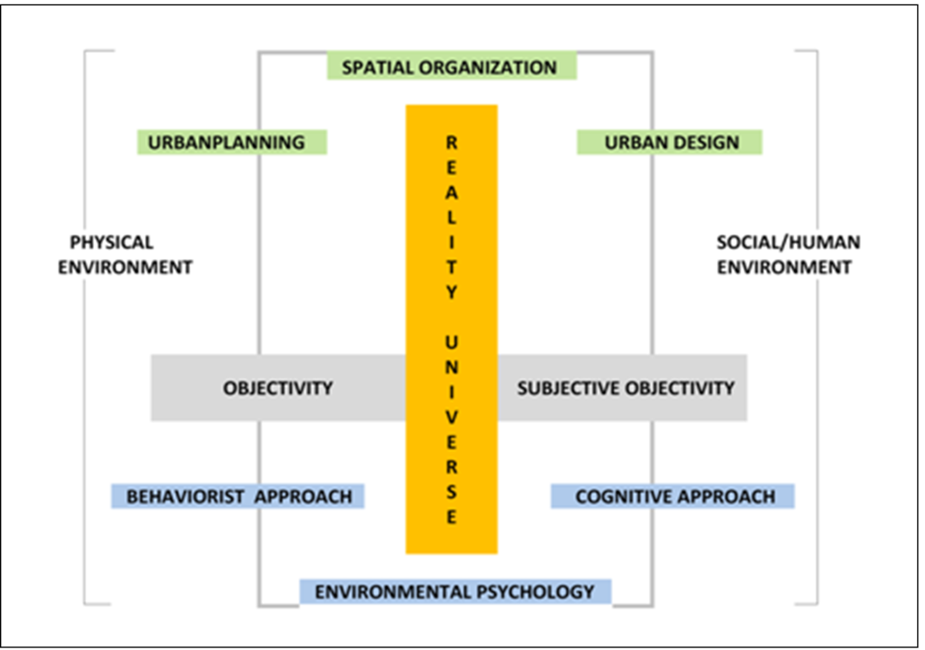
Figure 1. Integration of Spatial Organization With Environmental Psychology In Reality Universe (IŞIKPINAR, 1995)
3.0 The Transactional Perspective
Environmental psychologists Altman and Rogoff classifies four world views dominant in the fields of psychology, namely, trait, interactional, organismic, and transactional. Bringing down this classification from philosophers who have studied the phenomena inherent behind aesthetics, they base their argument on Aristoteles’ fourfold classification of causation in natural phenomena, namely, material cause, efficient cause, final cause, formal cause. They come up with the basic saying that with its ecological, in the philosophical sense, transactional world views are the most suitable to planning and design (Altman et al, 1987).
3.1 Aristoteles’ Fourfold Classification of Causation in Natural Phenomena
• | The first type of cause is ‘material causation’ and it is central to trait perspectives. A material cause involves “a substance (such as genes) having certain qualities that set limits on behaviour. Consistent with material causation, trait approaches assume that psychological causes are self-contained in the phenomenon itself and are ingrained qualities of material “essenses”.
• | Aristoteles‘s second concept of ‘efficient cause’ is based on antecedent-consequent relations between variables, whereby it is presumed that an antecedent variable is a “cause” if it is systematically associated with variations in a consequent variable. This conception of causation is central to contemporary science and is associated with an interactional world view.
• | The third Aristotelean conception of causation ‘final cause’, emphasizes predetermined directions, goals or end states toward which phenomena gravitate. Final causation is ‘teleological’, with a phenomenon operating in accordance with a pre-established end or purpose toward which it is pulled. Organismic world views emphasize this approach of causation, as do certain orientations that include final cause conceptions for growth.
• | The fourth Aristotelean approach to causation is ‘formal cause’, which focuses on the pattern, shape or organization of a phenomenon in a given set of circumstances. Formal causation can also involve analysis of the pattern or configuration of a phenomenon in a given context without use of universal explanatory principles. The concepts of formal causation are consistent with a transactional world view.
3.2 World Views in Psychology
• | ‘Trait’ world views focus on person, psychological qualities of persons, as environments play secondary roles. They usually assume stability; ‘Change’ is infrequent in present operation; change often occurs according to pre-established teleological mechanisms and developmental stages.
• | ‘Interactional’ world views, traditionally dominant in contemporary psychology, treats psychological processes, environments as independently operating issues based on Newtonian Principles of cause and effect and they are deterministic. ‘Change’ results from the integration of separate person and environment entities.
• | ‘Organismic’ world views take as their unit of study the integrated system. These approaches take the system as made up of separate elements whose patterns of relationships comprise the whole. ‘Change’ results from interactions of person and environment entities. ‘Change’ usually occurs in accord with underlying regulatory mechanisms, e.g., homeostasis and long range directional teleological mechanisms, i.e., ideal developmental states. It becomes irrelevant once ideal state is reached; assumes that system stability is goal.
• | In ‘transactional’ world views the whole is a confluence of inseparable factors that depend upon one another and conjointly define the whole. “Transactionalism implies a pragmatic, eclectic and relativistic approach to psychological phenomena and it is the most suitable approach for environmental psychology.” In transactional approaches, “... stability / change are intrinsic and defining features of psychological phenomena, ‘Change’ occurs continuously, directions of change are emergent and not pre-established.” (Altman et al, 1987).
A possible compendium of the four approaches and their relation to complexity types is schematized in Figure 2.. In this schema the four causes are illustrated as the basic primary concepts which are transformed into the four world views in psychology. The trait approaches, pre-established teleological, are visualized as relating to complexity Type 1. The interactional approaches with antecedent-consequent relational aspects, to Complexity Type 2. The teleological organismic approaches to Type 3, and the transactional with its ecological and contextual aspects to Type 4. Certainly these assertions are open to interpretation and evaluations. For instance the temporal aspects of the interactional world views can be questioned in respect to the time aspect of complexity type 2 which appears as a more dynamic aspect as it is regarded in complexity type 1.
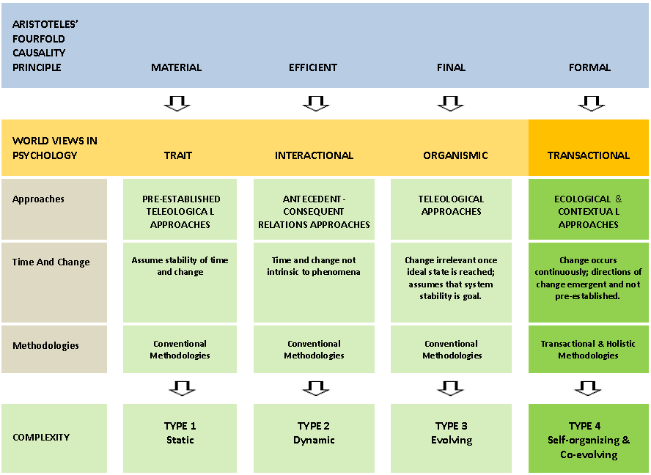
Figure 2. Aristoteles’ Fourfold Causality Principle, World Views in Psychology, Transactional Perspective and Complexity Type 4.
3.3 Transactional Approaches in Environmental Psychology
Altman and Rogoff summarizes the extent of the transactional approaches in environmental psychology by referring to several scholars. They state that transactional world views have been salient in the writings of the pioneers in the field of environmental psychology as early as the 70’s. . These writings included that there is absolute integrity of person/physical setting events, and understanding the mutual relationship between human behaviour and experience and the dimensions of physical settings is necessarily footed in the methodology which preserves the integrity of these events. Another assertion had been that man is never concretely encountered independent of a situation through which he acts, nor is the environment ever encountered independent of the encountering individual. It is meaningless to speak of either as existing apart from the situation in which it is encountered. They state
that already accepted in principle these views have not been translated into theoretical and empirical work except in the ecological research of social psychologist Roger Barker and his associates. A central concept for understanding the dynamic quality of person-environment relationships is the behaviour setting . (Altman et al, 1987)
Altman and Rogoff mention the transactional approach in several fields. Transactional concepts evident in anthropologically oriented research and theory define the environment as a complex and systematic organization of space, time and communication. Transactional perspectives are salient in cross-cultural studies in which homes are conceptualized as inseparable unities of people, places, and psychological and social processes that exhibit different qualities of change. Phenomenological approaches to person-environment relationships focus on the subjective and experiential aspects of person-environment relationships and are concerned with meanings, feelings of attachment and affective orientations of people to places. Environmental psychologist Irwin Altman’s dialectic analysis of privacy regulation illustrates the transactional approach. Change is essential to transactional theory , with social interaction treated as a dynamic and changing interplay of openness/closedness to others. (Altman et al, 1987)
Principles of Methodology in Transactional Research,
• | Takes settings and contexts into account
• | Seeks to understand the perspective of the participants in an event
• | Attempts to understand the observer as an agent of events
• | Accepts the relativity of indicators and measures of psychological functioning
• | Emphasizes the study of process and change
• | Accept the relativity of indicators and measures of psychological functioning
• | Emphasize methodological eclecticism
In summary, transactional orientations are unique approaches to the study of psychological phenomena in several respects :
• | They are holistic and treat the confluence of psychological processes and environmental contexts as the fundamental unit of analysis.
• | Persons, processes, and contexts mutually define one another and serve as aspects of the whole not as separate elements.
• | These aspects do not combine to yield the whole; they are the whole and are defined by and define one another.
• | In addition, temporal factors are intrinsic aspects of the transactional unity, with degrees of stability and change being fundamental properties of phenomena.
• | Also, although they may attempt to establish general principles psychological functioning, transactional world views do not necessariIy seek universal principles that are presumed to govern all facets of a phenomenon
• | Different explanatory principles may emerge in different circumstances: change may evolve from unique confluences of psychological processes and environments; long-range directional and teleological principles are not assumed: and variability of psychological functioning is expected.
• | And transactional views emphasize a formal cause approach to understanding wherein the goal of research and theory is to account for describe, and understand the pattern of relationships among people, places and psychological processes.

Altman and Rogoff discuss the efficacy of as to which of the four world views is most fruitful to use. They state that non of these, they result in different forms of inquiry, understanding and theory. They advocate the complementary use of alternative world views. As stated also by other scholars different world views are acceptable and serve different purposes.(Altman et al, 1987) . Werner and colleagues asserts as well that many research projects contain more elements of more than one world view, each world view makes valuable contributions to understanding the phenomena. (Werner et al, 2002). Keeping these assertions the focus of this paper will be on the transactional approach to be able to get a clear perspective.

Transactional perspectives favor two main approaches : the ecological psychology approach and the contextual approach..
Ecological Psychology Approach
The initiating point for the work administrated in ecological psychology first came of an attempt to evaluate the influence of behaviour settings on people. Traditionally, it was believed that behaviour is dependent on the individual primarily. Barker and Wright after investigating the records of children came to conclude that behaviours of children could be predicted more accurately from knowing the situations the children were in rather than knowing individual characteristics of people. The records showed that though children’s behaviour did not exhibit complete uniformity, when the entire range of behaviours was under question they did so. Thus the shift from in focus from persons to environments had started. (Wicker, 1984)
The central concept of ecological psychology is the behaviour setting: “A bounded, self-regulated and ordered system composed of replaceable human and non-human components that interact in a synchronized fashion to carry out an ordered sequence of events called the setting program.” (Wicker, 1984). These basic considerations of the field apparently directs the attention to the evolving and co-evolving capacity of its approach. Self-regulated aspects of the setting concept are in accord with the self-evolving aspect of spatial planning as required by complexity theory.
Essential features of a behaviour setting can be shown as follows : (Wicker, 1984)
• | Behaviour settings are ‘real’. In this context some concepts in psychology, like attitudes and motives, are convenient fictions or abstractions,
• | Behaviour setting has ‘boundary’ with two components, human and nonhuman. Within this boundary, an orderly pattern of behaviour that follows a ‘program’, a prescribed sequence of interactions between people and objects in the setting is preset,
• | The combination of coordinated behaviours and objects is called a ‘synomorph’. The parts of the setting, the human and nonhuman components, have a synomorphic relationship with one another, actions and objects fit compatibly together. Within a behaviour setting, the human and nonhuman components are more closely interconnected than they are with components of other settings.
• | Another feature of the behaviour setting is the ‘substitutability of persons’ within them
• | Another feature, which is crucial to having insight of an overall understanding of ecological psychology is that, “Behaviour settings are self-regulating, active systems.” They impose their program of activities on the human and the nonhuman component, essential persons and materials are drawn into settings, and disruptive components are modified or rejected.
• | Behaviour settings are dependent upon some minimum number of persons to carry out the setting program.
• | Within any behaviour setting a number of specialized mechanisms act to assure that the essential activities are carried out. These are the sensing mechanisms, executive mechanisms and maintenance mechanisms.
These mechanisms of the self-regulating processes are listed by Wicker as follows. ‘Sensing mechanisms’ receive information about events in the setting and the information thus acquired is continuously relayed to ‘executive mechanisms’ which may decide for the maintenance mechanisms to come into action. Thus when a threat to the setting ‘s program or to a person’s satisfaction in the setting occurs, two ‘maintenance mechanisms’ become active : ‘deviation-countering mechanisms’ and ‘vetoing’. Deviation-countering mechanisms are the actions aimed at altering, shaping, correcting or counteracting the threat or interferences (e.g., the changing of furniture for a better setup) . The second kind is the vetoing , in which case the source of the threat is ejected from the setting. (e.g., the exclusion of a human component for noise). (Wicker, 1984)
This concept of the self-regulative and active system is much in parallel with the concept of evolution and co-evolution. It is in fact a very convenient description of the spatial planning process indicative of a holistic approach based on temporal and spatial dimensions. The problems initiated in cities of today by the disrupted physical environments and the shortages of spatial planning confronting the impacts of urbanization, social density, environmental pollution are phenomenon which can be investigated through this conceptualization.
Referring to the above explained, Altman and Rogoff argues that, “...a behaviour setting is a confluence of actions in relation to places and things; these actions are organized in systematic temporal sequences and patterns. Behaviour, places, and temporal dynamics are mutually interlocked such that behaviour gains meaning by virtue of its location in a particular spatial and temporal context.” (Altman et al., 1987). This definition pointing to the spatial and temporal dimensions completes the picture of the holistic approach required in system’s analysis through Complexity Theory.
“Wicker states that for the ecological psychologists the environment is ‘well structured’, and they try to ‘identify’ the ecological units. The basic ecological unit, the behaviour setting, is a part of a hierachically nested series of smaller and larger settings like the layers of an onion. Each behaviour setting of a system is a component of a larger system, whereas it enhances a number of smaller systems. It is this very aspect of ecological psychology approach that makes it very suitable for use in planning and urban design. The city is essentially composed of a hierarchy of nested series of spaces, open and closed spaces, public squares, gardens. If, for example, a person’s house is a component of his neighborhood, whereas the rooms are the components of the house in a hierarchical set-up. (Wicker, 1984). Ecological psychology offers the possibility of evaluation of such systems in a holistic hierarchical sequence.” (Işıkpınar, 2004)
This conceptualization of the system of settings at more comprehensive and encompassing scales than the individual setting, interrelative and interactive confluence of a system of settings is under consideration, and can therefore be suggested as another basic aspect of the contributions to Spatial planning in terms of Complexity Theory.
The second important approach favored by transactional world views is the ‘contextual’ approach.
The Contextual Approach
Stokols, accentuates that, “A fundamental feature of transactional research is its emphasis on the dynamic interplay between people and their everyday environmental settings, or ‘contexts’” (STOKOLS, 1987). Stokols states that the contextual perspective in psychology is associated with four core assumptions. The first is, psychological phenomena should be studied in relation to their spatial, temporal, and sociocultural milieu; the second is, focus of research should be on people’s everyday activities and settings and analyses of these issues should be more molar and continuous; and the third is, the situation specificity of psychological phenomena should be more sensitively taken under consideration against the search for lawful relations of behaviour and environment. The fourth is, the criteria for ecological and external validity should be considered at all stages of behavioural studies starting with the design of them to the development of public policies and community interventions. (Işıkpınar, 1994)
Stokols argues that underlying the notion of contextual research is the concept of embeddedness. The issue here is that, “... a particular phenomenon is thought to be embedded in (and influenced by) a surrounding set of events. Contextual research identifies first of all the central or target phenomenon, then tries to define a set of situational or contextual variables that are thought to effect the form and occurrence of the target phenomenon.” (Stokols, 1987). He states that what separates a non-contextual research from a contextual one is that, while the former focuses on the relationships between target predictor and outcome variables, the latter incorporates supplementary predictor variables drawn from the immediate situation. (Işıkpınar, 1994)
To be able to explain the dynamics of the external physical and social environments a third approach which is favoured by most areas dealing with the human being is the cognitive approach. The ecological psychology approach is behaviouristic, based on external observations. The contextual approach is basically a systematic approach which can be be applied to any phenomenon.
The Cognitive Approach

To be able to explain the dynamics of the external physical and social environments a third approach which is favoured by most areas dealing with the human being in interaction with the external world is the cognitive approach. The ecological psychology approach is behaviouristic, based on external observations. The contextual approach is basically a systematic approach which can be applied to any phenomenon.
The Cognitive Approach came about in part due to the dissatisfaction with the behaviourist approach, which focused on visible behaviour without understanding the internal processes that create it. The approach is based on the principle that our behaviour is generated by a series of stimuli and responses to these by thought processes. Cognitive psychology offers a viable approach which has been used to create the multi-store model of memory processes, supported by many other experiments. Easily combined with other approaches it takes into account the internal, invisible thought processes that affect our behaviour, unlike the behavioural approach it depends largely on controlled experiments to observe human behaviour, which may lack ecological validity (being compared to real-life behaviour). (Psychologist World, 2011)
People have their own ways of perceiving, attitudes, desires and numerous personal preferences in relation to the environment. The process of creativity shapes all these phenomena and these processes are all related to the unconscious. ‘Cognitive psychology’ offers the urbanist the possibility of obtaining the evaluations of the urban people’s preferences which means awareness of the environment and thus making reflections of public participation possible to planning and design. A fundamental concept in this context regarding the perception of the environment is Gibson’s concept of affordances. Lang discusses the concept in relation to design professions. The affordance of anything, be it material or nonmaterial, are those of its properties that enable it to be used in a particular way by a particular species or an individual member of that species. Different patterns of the environment afford different behaviours and aesthetic experiences. The concept of affordances is fundamental to design theory. (Lang, 1987)
4. Implementations on Planning : A Case Study
The implications of the theoretical framework to spatial planning exhibited above had been conducted by the author of this paper in several towns and cities empirically and pragmatically. The study was conducted in European Turkey, Marmara and North-western Anatolia regions of Turkey (Figure 3.) (Işıkpınar, 1995). The study was undertaken within the general framework of the Planning Department of İllerbank, the Municipalities Bank of Turkey, affliated to the Ministry of Public Works, responsible for financial and technical assistance to municipalities. (İllerbank, 1974-1997)
The locations of the towns and cities investigated are given in Figure 3.
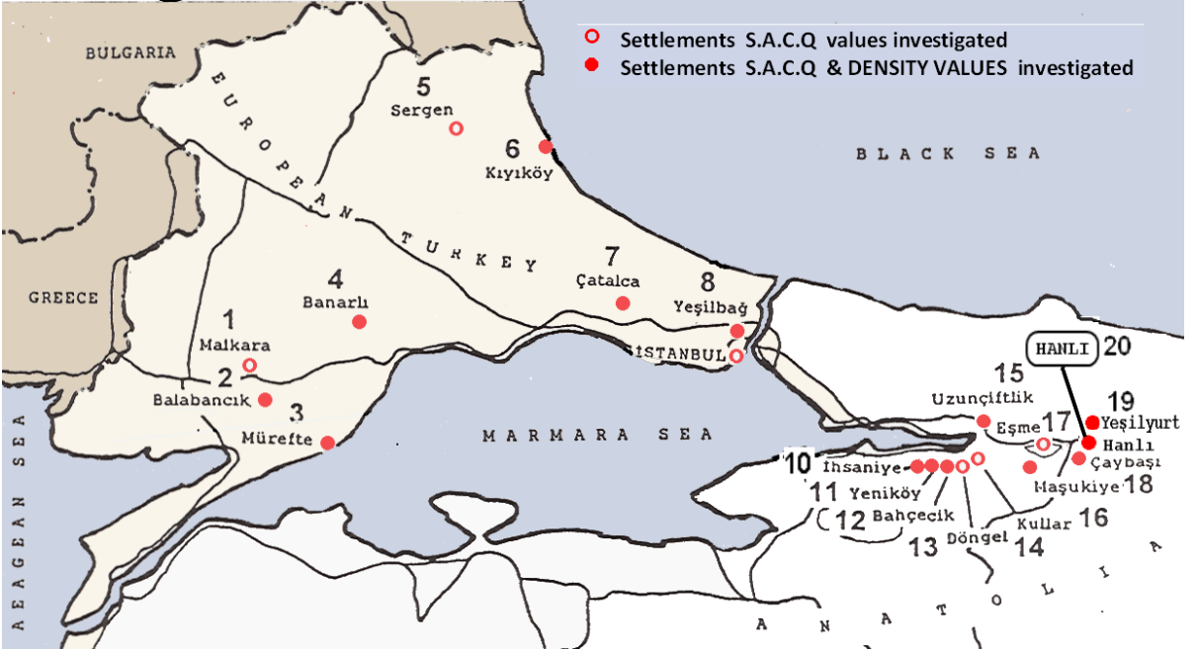
Figure 3. The Settlements investigated.
4.1 The Eclectic Methodology
The eclectic approach has four phases. In the First phase all demographic data for each settlement is collected. In the Second phase interviews are conducted with the actors involved in the urban life of the settlement under question. Based on demographic data and the interviews, formal questionnaires are prepared and administered to the interested parties. In the Third phase, work is conducted based on Ecological Psychology. The findings of S.A.C.Q. values makes a hierarchically nested investigation of cities’ social and economic potentials possible. In the Fourth phase, each setting (or space or place) is taken individually one by one whereby the emotional load of the environment is evaluated through environmental psychology and cognitive psychology approaches. Thus a matrix of internal, mental, subconscious preferences is achieved to constitute the eclectic phase of the survey for the assessment of the affordances of the physical settings.
The Ecological Psychology Methodology
As stated before, an approach which would represent and project the real world is required. Ecological psychology presents such an approach.
The main approach employed in the planning oriented investigation was based on the transactional perspective. As the pragmatic approach ecological psychology was utilized. Methodology covered the following main points :
• The demographic data acquired from statistics and interviews were utilized.
• | The basic unit of evaluation was at the parcel scale
•  • | For each parcel a social activity value dependent on the intensity of the activity on that parcel was determined .  A unit value named S.A.C.Q. (social activity constructional coefficient) was acquired by dividing social activity values by the number of parcels.  [social activity(SA)/parcel(P) = sacq]
• | In parallel with Manning Theory formulated by Barker, which states that a setting ceases to exist when it is not occupied (Barker, ), the sacq values for unoccupied parcels for any reason, be it barren or deserted, were accepted to be 0.00 (0.00 SA/ P=0.00). The values obtained for the settlements investigated can be followed on Columns 1, 2, 3 in the SACQ Table.
Thus a sheet showing the sacq values was obtained, which was named the ‘Urbanization Process’, since the sheet indicated the position of urban development in the transitory period from the rural to the urban. (Figure 4.)
The Cognitive Psychology Methodology
In the Cognitive Psychology phase each setting (or space or place) is taken individually one by one whereby the emotional load of the environment is evaluated through environmental psychology approaches. Thus a matrix of internal, mental, subconscious preferences is achieved to constitute the eclectic phase of the survey for the assessment of the affordances of the physical settings configuring the urban scene such as the following :
• Citizens preferences for main city functions,
• People’s reactions to the introduction of these new functions,
• People’s reactions to crowdedness and spaciousness,
• The image and identity of the city,
• The shape, layout and other physical characteristics, of public spaces, streets, and other urban elements. (Işıkpınar, 2009)
Characteristics of the Settlements Investigated
The general characteristics of the towns and cities investigated are below :
Population range | : | Variable between 2006-21000 p. with a mode of 2000-5000 p.
Populated area | : | Variable between 18-1344 ha, with a mode of 75-250 ha.
Population density | : | Variable between 4-650 p/ha, with a mode of 50-150 p/ha.
Main City Functions | : | Agriculture, small and middle scale industry.
“Development in these settlements has been self-regulative, evolving and co-evolving during the last decade before 1995.”
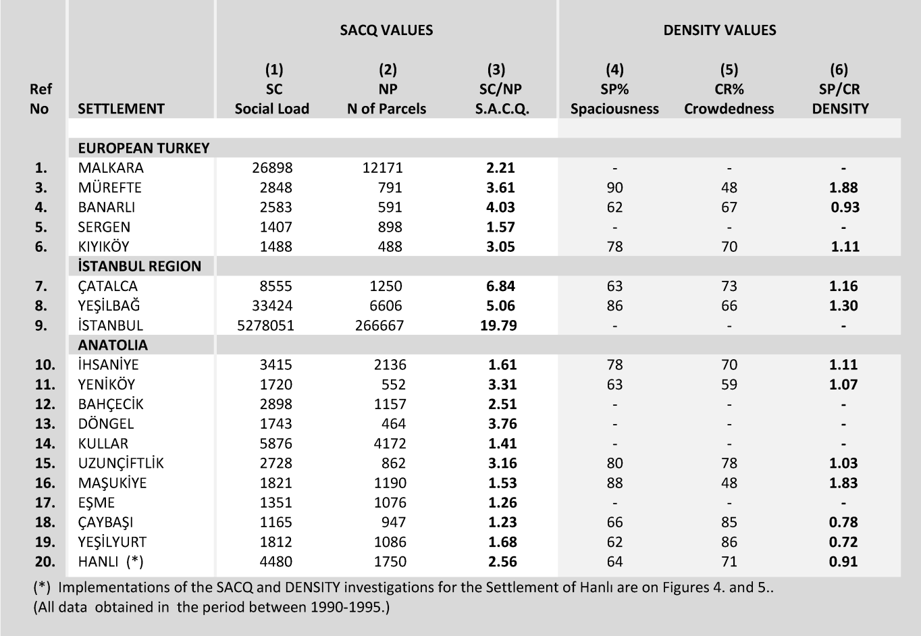
The SACQ (Columns 1-3) and DENSITY (Columns 4-7) values obtained through the investigation of the settlements are given in the following table :
Table. SACQ & DENSITY Values for the Settlements Investigated
The values in the table can be paralleled with the basic phenomena Complexity Theory deals with. The SACQ values stand as representative of the ‘resilient’ potential of the settlement, whereas the cognitive values such as DENSITY for the ‘panarchical’ transactions of dynamic relations. ‘Fuzzy logic’ can be utilized in the evaluation of the incremental investigation of the several factors as acquired from cognitive data in that a required flexibility can be achieved.

A Specific Case : The Settlement of Hanlı (Table, Ref No.20.) (Illerbank, 1995)
A specific example chosen for illustration is the Settlement of Hanlı with the following demographic characteristics in the year of 1995 :
Main City Functions |  | : | Housing, Agriculture, Industry
Population |  | : | 2,867 p
Total Populated Area |  | : | 29.80 ha
Density |  | : | 96 p/ha.
Development |  | : | Self-regulative, evolving and co-evolving during the last decade during the period before 1995.
“The Settlement of Hanlı is under the pressure of industry and housing”

An example of the major findings of the data from the above table concerning the settlement of Hanlı are as follows :
• The sacq value for the settlement of Hanlı appears to be in the first quarter of the sacq ranking scale (sacq=0.91). (The upper limit of the ranking scale for Turkey has been accepted to be 20.00 sacq) This value is low as compared to the other settlements with similar urban characteristics.
• The result obtained from this single example has indicated that although the population density is low as compared to the other settlements studied, the inhabitants reacted negatively to further increase of density because of the fact that Hanlı is already under the pressure of industry and the possible housing expansion of the administrative center of Adapazarı which is 7.0 km. only. In other words, increase of density of population was not desired, thus resulting in a low-density settlement so far as planning is concerned, which means low housing as well. This situation was one of the major issues effecting the Master Plan of Hanlı.

Implementations of the findings at the planning phase are as follows :
• Implementations of the sacq values makes possible a linearly projected replica of the layoutof the settlement under investigation which reflects the present social and economic potential of the settlement. Thus a basic data sheet is achieved. (Figure 4.)
• Implementations of the cognition values of the inhabitants’ preferences are exhibited in (Figure 5.)
• The data acquired from these sheets are superposed with the several sheets relating to the demographic and physical aspects of the settlement, such as historical development, topography, climate. (Figure 6.)
Finally, abiding by the classical spatial planning principles and utilizing the data thus acquired The Master Plan is achieved : (Figure 7.)

 | 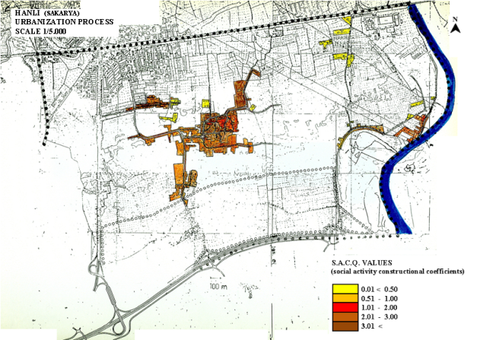 |  |  | 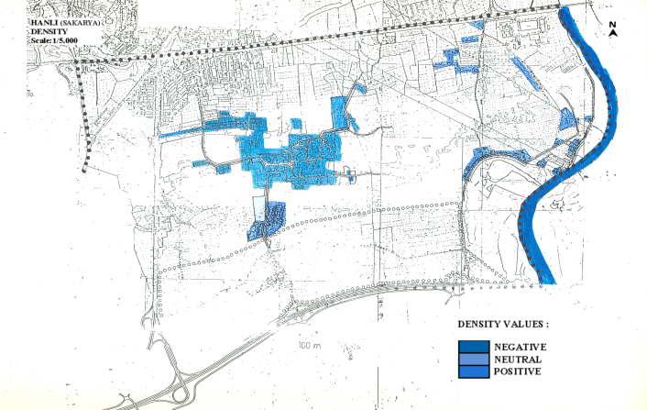
 | 1. Objective (SACQ) Values Sheet of Hanlı |  |  | 2. Subjective (Density) Values Sheet of Hanlı
 | 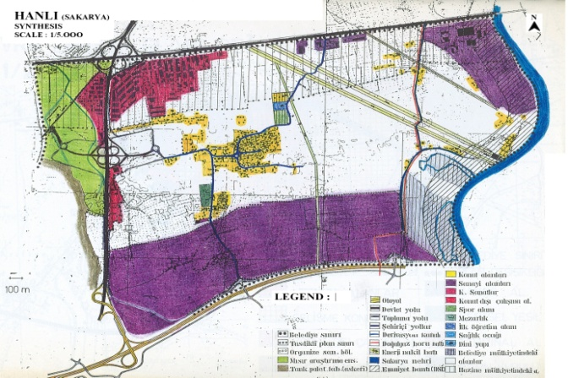 |  |  | 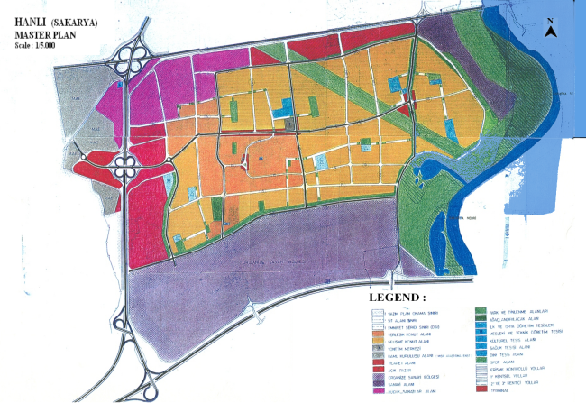
 | 3. Synthesis Sheet of Hanlı |  |  | 4. Master Plan of Hanlı
 | Figure 5. Some of the Objective & Subjective Evaluations for the Settlement of Hanlı

• The comprehensive statement about a world of change, “… the spatial environment is considered to be evolving non-linearly and alternating between stable and dynamic periods. (De Roo, 2011, De Roo et al, 2010) If the environment that is subject to change is adaptive, self-organizing, robust and flexible in relation to this change, a process of evolution and co-evolution can be expected.” (Gert De Roo, 2011) is in compliance with the definition of the transactional perspective.
• “A prototype definition of psychology for transactional approaches is the study of the changing relations among psychological and environmental aspects of holistic unities.” The unit of analysis is holistic entities such as events involving persons, psychological processes and environments. The transactional whole is not composed of separate factors but a confluence of inseparable factors that depend on one another for their very definition and meaning focusing on the temporal relationships among aspects of this whole. (Altman et, 1987).
• A definition of Complexity Theory is as follows : “Complexity Theory states that critically interacting components self-organize to form potentially evolving structures exhibiting a hierarchy of emergent system properties.” (Lucas, 2006)
Taking into consideration the above statements the following remarks can be asserted in relation to some of the basic phenomena in the sphere of investigation of the complex systems approaches :
• A definition of ‘Resilience’ is, “The capacity of a system to absorb disturbance, undergo change, and retain the same essential functions, structure, identity, and feedbacks.” (Longstaff et al, 2010). In accordance with this definition, the transactional approaches offer the stances of individual spatial systems temporally, the ecological settings, by the possibilities of evaluating each setting primarily within its internal dynamics. Resilience refers to the inherent existing potential of the systems which is a basic approach in ecological psychology.
• A widely accepted definition of ‘Panarchy’ is,“…the structure in which systems, including those of nature (e.g., forests) and of humans (e.g., capitalism), as well as combined human-natural systems (e.g., institutions that govern natural resource use such as the Forest Service), are interlinked in continual adaptive cycles of growth, accumulation, restructuring, and renewal.” (Gunderson et al, 2002) This definition is in parallel with the transactional approaches in that they make the study of the individual systems with the surrounding systems in interactive dynamics possible . Ecological psychology gives the possibility of analyzing such an array of systems starting from the individual settings systems scale to the complex systems in hierarchical and panarchical interrelations, as stated above in the paper ‘in like manner as the layers of an onion’.
• A common definition of fuzzy logic states that ’Fuzzy Logic’ as originated by Zadeh, “… is a superset of conventional (Boolean) logic that has been extended to handle the concept of partial truth-truth values between ‘completely true’ and ‘completely false’” (Ierapetritou, 2001) The implication in this context would be that ‘fuzzy logic’ can be utilized in the evaluation of the incremental investigation of several factors from the cognitive data acquired. ‘Fuzzy logic’ as a concept contradictory to determinism, the common problem creating issue in spatial planning, is in parallel with the transactional approaches in that they offer the possibility of investigating each and every aspect of the environment in a transactional amalgam of human characteristics. Transactionalism enhances all causes of realization, determinist, indeterminist or immanently oriented , therefore rendering the fuzzy investigation of systems in hierarchical order with efficiency.

References
Altman, I. and Rogoff, B. (1987) World Views In Psychology : Trait, Interactional, Organismic, and Transactional Perspectives, in: Daniel Stokols and Irwin Altman, Handbook of Environmental Psychology, Chapter 1, A Wiley-Interscience Publication, John Wiley and Sons, New York, U.S.A., pp.7-41..
Churchman, A. (2002) Environmental Psychology and Urban Planning: Where Can the Twain Meet?, in: Handbook of Environmental Psychology, Eds. Robert B. Bechtel And
Arza Churchman, Chaper 12., John Wiley and Sons, Inc., New York, pp.193-202
Çubuk, M. (1973) Beşeri Yerleşmelerde Mekan Organizasyonu ve Ülkesel Kalkınmayı Bir Mekan Organizasyonu İçinde Yaratmak, (Eng. Spatial Organisation in Human Settlements and Creating Country-Wide Development in a Spatial Organization) İstanbul Devlet Güzel Sanatlar Akademisi : 74 (İstanbul State Fine Arts Academy Faculty of Architecture) İ.D.G.S. Akademisi Mimarlık Fakültesi Şehircilik Kürsüsü Yayını, 1, Docent’s Thesis.
Davis, J.V. (2006) Ecopsychology and Environmental Psychology, Retrieved on 12, October 2009 from website: http://www.johnvdavis.com/ep/index.htm.De Roo, Gert and Elisabete, A. S. (2010) Planning and Complexity : An Introduction, in: a Planner's Encounter With Complexity, Gert de Roo, and A.S.Elisabete, (Eds.), Ashgate Publishing Limited, England, pp.1-18.
De Roo, Gert (2011) Self-Organizing and SpatialPlanning, Opening Speech, in: Self-Organizing and Planning, 9th Meeting of AESOP Thematic Group on Complexity and Planning, Yıldız University, İstanbul, Turkey.
De Young, R. (1999) Environmental Psychology, in Encyclopedia of Environmental Science. in: D. E. Alexander and R. W. Fairbridge, Hingham, MA: Kluwer Academic Publishers, USA..
Gunderson, L., and C.S. Holling (Eds.), 2002. Panarchy: Understanding Transformations In Human and Natural Systems, Island Press, Washington, D.C., USA..
Ierapetritou, M. (2001) Bilevel Optimization: Feasibility Test And Flexibility Index, in: Encyclopedia of Optimization, in : C.A. Floudas and P.M. Pardalos, Kluwer Academic Publishers, Vol. 1, pp. 144-154.
Işıkpınar, M.E.(2009 ) Ecocentrism : Environmental Awareness, in:Ecocity 2009 Proceedings, İstanbul,13-15 December 2009, Ecocity Builders, E-Book, pp.622-633.
Işıkpınar, M.E. (2004) Şehirler ve Çevresel Psikoloji, Disiplinlerarası Şehir Araştırmaları Sempozyumu (Cities and Enviromental Psychology, Interdisciplinary Urban Research Symposium), in : Oya Okan ve Ayşen Şatıroğlu, İ. Ü. Edeb. Fak. Sosyoloji Dergisi, 3. Dizi-9.Sayı, 2004, İ.Ü. Yayın No. 4533, İstanbul Üniversitesi Sosyoloji Araştırma Merkezi, 13-14 Mayıs 2004, İstanbul Üniversitesi Edebiyat Fakültesi (İstanbul University Faculty of Letters), İstanbul, pp.63-106..
Işıkpınar, M.E. (1995) Çevresel Psikoloji ve Mekan Etkileşimi: Mekan Düzenlemede Psikolojik Boyut Gerekliliği Üzerine Yöntemsel Bir Araştırma, (Eng., Environmental Psychology and Spatial Interaction: A Research On the Necessity of the Psychological Dimension in Spatial Organization), Mimar Sinan University Department of City and Regional Planning, Ph. D. Thesis, Turkey, 182 p., unpublished.
Işıkpınar, M.E. (1994) Planning And Designing For Change and Heterogeneity Require New Insights Into Human Dimensions, 8th AESOP Congress,: Planning For A Broader Europe, Association of European Schools of Planning and Yıldız University, İstanbul, 24-27 Ağustos 1994, pp.418-438.
İllerbank (1974-1997) Period Reports on Planning Conducted at İllerbank, İller Bankası Genel Müdürlüğü, (Eng. General Directorate of İllerbank), Ankara: İllerbank Publications, Turkey, in Turkish.
İllerbank (1995) Hanlı Master Plan, İllerbank Regional Directorate 1, İstanbul Urban Planning Bureau, the İllerbank Archives, Ankara, Turkey, in Turkish.
Ittelson, W.H., Proshansky, M., Rivlin, L.G., and Winkel, G.H. (1974) An Introduction to Environmental Psychology, ed. David Dempsey, Holt, Reinhart and Wilson Inc., printed in the United States of America, U.S.A..
Lang, J. (1987), Creating Architectural Theory, The Role of the Behavioural Sciences in Environmental Design, New York: Van Nostrand. 32, pp. 77-83.
Lucas, C. (2006) Quantifying Complexity Theory, Page Version 4.83 June 2006 (paper V1.2 October 2004, Original April 1999), Retrieved on 10 May 2011 from http://www.calresco.org/lucas/quantify.htm.
Psychologist World, Cognitive Approach (Psychology), 2006-2010 Psychologist World and partners, Psychologist World com. Retrieved on 5 May 2011 from http://www.psychologistworld.com/cognitive/approach.php .
Stokols, D. (1987) “Conceptual Strategies of Environmental Psychology”, in: Daniel Stokols and Irwin Altman, Handbook of Environmental Psychology, Chapter 2., A Wiley- Interscience Publication, John Wiley and Sons, New York, U.S.A., pp.41-70.
Zuidema, C.& De Roo, Gert (2001) Integrating Complexity Theory Into Planning: Truth Or Dare: University of Groningen, Holland. Retrieved on 20 May 2011 from http://www.ruimterijk.nl/index/publicaties/publicaties/DeRoo%20Zuidema%202004%20Aesop.pdf..
Longstaff, P H., Armstrong, N. J., Perrin K, M.P. Whitney and Hidek, M. A. (2010) Building Resilient Communities: A Preliminary Framework for Assessment, Homeland Security Affairs: Article, Volume VI No. 3: September 2010.
Werner, C.M., Brown, B.B. and Altman, I. (2002) Transactionally Oriented Research :
Examples and Strategies, in: Robert B. Bechtel and Arza Churchman, Handbook of Environmental Psychology, John Wiley and Sons, Inc., New York, John Wiley and Sons, Inc., New York, pp.203-221.
Wicker, A.W. (1984) An Introduction to Ecological Psychology, Cambridge University Press, Cambridge, Cambridge, England.

