SUBJECTIVITY AND OBJECTIVITY: CORE CONCEPTS FOR URBAN DESIGN

M. Ertürk IŞIKPINAR, PhD. Urbanist, M.Arch., Ülkü IŞIKPINAR, M.A.Sociologist.
IŞIKPINAR PLANNING AND DESIGN CONSULTING

ABSTRACT
Since the early decades of the 20th Century the analysis of urban architecture has been a complex phenomenon. As stressed by postmodern philosopher Jean Baudrilliard in the last decade of the past century, “the urban social is ineffective, neutral, the entity called social is lost, and replaced by masses, finally the simulation of the social is under consideration.” (Baudrilliard, 1982 )
The basic issue within this context is that interactions in the urban scene occur in two spheres : environmental and human. The environmental sphere is an interplay of the natural and the built environments where phenomena are dependent on objective laws of determinism basically. The human sphere however is governed by the laws of determinism, subjective laws of indeterminism and immanent orientation.
The acquiring of the data basic to urban design is another complicating issue. So far as the urban environment is concerned the classical trend has been planner centered and the approach is treated as objective. The evolving trend calls for a user centered, subjective approach. Postmodernity evolved in the last decades announced the dominating trend of singularity against the plural, hence subjectivity.
Another point is that the wide proliferation of concepts such as aesthetics, creativity, authenticity, autonomy complicate the designers approaches. Two core concepts pertaining to all these phenomena are subjectivity and objectivity. The approaches to the urban scene provide data and evaluations based on explicit behavioral tendencies considered as objective. The human interacts with the environment through objectively as well as subjectively shaped perceptual and cognitive assessments.
A common feature pertaining to all these phenomena is subjectivity versus objectivity. The long standing dilemma as to the basis of approaches standing in the field of architecture is the debate as to the priority of subjectivity and/or objectivity. Objectivity requires features such as lack of bias, judgment, or prejudice, external or material reality. Subjectivity requires intentness on internal thoughts, internal reality basically. Despite these classical definitions and approaches, the long standing experience in dealing with urban life reveals two issues : an approach to the urban should cover both the subjective and the objective, and secondly data objectivity can be handled through subjective approaches, thus the coining of the concept of ‘subjective objectivity’.
In the paper, an analyses of the urban objective and subjective interactions will be handled through an eclectic approach based on psychology, sociology and ethics.

Key Words. Objectivity, subjectivity, subjective objectivity, urbanism.

INTRODUCTION
The advent of the 20th Century had been the crest of numerous upheavals. World wars were created by humans, natural disasters accompanied them. The accomplishment of most advanced techniques made the creation of superstructures, super cities, megalopolises, however cities full of unhappy dwellers. The City Beautiful Movement of the 19th Century was one of the startling event of the struggle for reaching the ‘best’ urban environments. The functionalist movement of the Chicago School, interrupted by the world wars and other disastrous events, Action Planning approaches had not been satisfactory to achieve the best urbanities. (Gidieon,1963)
The main concern within this context lies in the fact that the physical and the social environments have not been interactive. The main issue interrelated to the insufficiency of harmony between the physical and the social environments lies in the fact that the urban social environments are designed to fit into the urban physical environments, where actually the physical environments should be designed to fit the social environments. A second issue is that the urbanist plays the role of the sole decision maker. The dweller, though in most societies is handed the right of choosing governments is not given the opportunity to decide for own habitats.

THE TRANSITION OF THE URBAN SCENE
An impressive metaphorical description of the transformations of the urban scene is conceptualized by the postmodern critique Baudrillard in his book A L’Ombre des Majorités Silencieuses ou La Fin du Social (BAUDRILLARD, 1991). Baudrillard conceptualizes the urban social as a knot turning continuously around both known and unknown masses. Statistics use these masses as crystal spheres. They are affected by currents and flows such as materials and natural elements. Although these masses absorb all the energy emitted by the social and the political, everything goes away sliding on them since they are not good transmitters. These masses do away with the bundles of light, namely State, History, Culture and Meaning, formed around them. In this state, they are ineffectiveness, and strength of neutrality. In short, the entity called social is lost, and replaced by masses, finally the simulation of the social is under consideration. Figure 1.
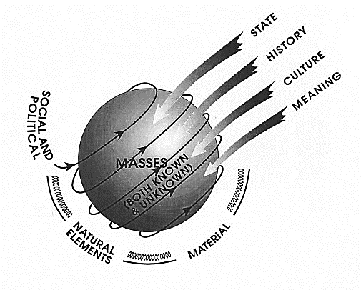 | 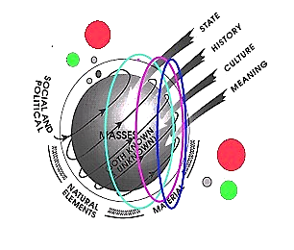
Figure 1. 20th Century : Baudriliard’s Crystal Sphere (Işıkpınar, 1995) | Figure 2. 21st Century Transformation

This was the appearance of the urban scene by the last decade of the 20th Century. The initializing decades of the 21ST Century fortunately came to exhibit a different appearance. An insightful glance at the appearance of the urban social in the first decades of the 21st Century reflects a complexity of social upheavals caused by wars, extensive masses of migrations, however a highly awakening of the world societies also as the result of the rising trend of interne use. The professionals started to realize the importance of the ”user” role of the urban dweller. Masses started to see the actual position of the natural environment, several circles initialized novel approaches such as the advent of the “Ecozoic Era”. The subjects and objects of the environment started to be perceived not only as the human being, but animals and plants came to be considered as members of the urban habitats. Baudrillard’s Crystal Sphere started to gain different target oriented social ‘satellites’ circling around the main body. Humankind and all other living creatures became the subjects of new insights, at the threshold of a new era. The crucial issue within this context is that the matter is psychological and sociological. (Figure 2.)
Main Issues of Failures In the Urban Scene : Determinism, Behaviorism, Empiricism.
Referring to several scholars, Işıkpınar argues that three main issues have been responsible for the unsuccessful urban environments so far as social sciences and urban planning and design are concerned: determinism, behaviorism, empiricism. (Işıkpınar, 1999)
The assertion here is that classical approaches to social sciences have been basically deterministic in parallel with the Newtonian Principle of cause and effect and can cope only with socio-cultural ‘mass’ events. In this context in parallel with the principles of Quantum Physics has made it clear that indeterminist approaches are under consideration as socio-cultural events cannot be dealt with in this manner because social events do not repeat themselves in exactly the same form, therefore cannot stand on rigid theories. A third sphere of socio-cultural systems is governed by immanent orientation laws and cannot be explained by either of these laws, they are essentially inlaid.
A second issue is that classical approaches in social sciences as well as in planning and design professions have been relying on ‘behaviorist’ approaches which are deterministic in the sense that they rely on observation and demography. To cope with the complex crisis in cities, approaches to study the latent mental processes are present as the cognitive approach, which studies the latent mental processes, and favored highly by psychologists as well as sociologists.
A third issue concerns ‘experimentation and theory building’ in social sciences also based on determinism. Nature has its regularly repeating events, instead social events never repeat themselves in exactly the same manner as asserted above. Consequently as it is not possible to generalize through the observation of repeating events, experimentation does not yield data on which sound theories and approaches can be established.
Following the long staking dominance of determinism the trends in the transition of the urban have been threefold in sequence.. Environmental determinism had been the view that the physical environment determines human behavior. Later ‘Possibilism’ has become the dominant view that the physical environment provides possibilities and constraints which people make choices on other, mainly, cultural criteria. ‘Probabilism’ has been the current view starting in the 90’S that the physical environment does, in fact, provide possibilities for choice and is not determining, but that some choices are more probable than others in given physical settings. (Rapoport, 1990)

THE SUBJECTIVE AND THE OBJECTIVE IN THE URBAN
Interactions in the urban scene occur in two spheres : environmental and human. The environmental sphere is an interplay of the natural and the built environments where phenomena are dependent on objective laws of determinism basically. The human sphere however is governed by the objective laws of determinism, subjective laws of indeterminism and immanent orientation.
The arguments on the subjective and/or the objective roots back to the 19th Century when the French philosopher Auguste Comte had put forth the Doctrine of Positivism. (Hewet, 2008). Positivism appropriates the idea that the phenomena dominant in the urban environment rely on experimental and observed realities. Positivism gets it background to the Age of Reason, or simply the Enlightenment thinkers in Britain, in France and throughout Europe questioned traditional authority and embraced the notion that humanity could be improved through rational change. (History, 2015) This pattern of reasoning inhibited human will, autonomy and authenticity. Age of Reason is an era from the 1620’s to the 1780’s in which cultural and intellectual forces in Western Europe emphasized reason, analysis, and individualism rather than traditional lines of authority.
Appearing reactively to positivism had been Hermeneutics and argues that humans and societies are real entities which create and share meaning and culture and therefore cannot be explained as objective physical entities. The term hermeneutics covers both the first order art and the second order theory of understanding and interpretation of expressions. (Stanford Encyclopedia of Philosophy, 2005). Hermeneutics argues that humans and societies emerge as meaning and culture creating and sharing entities and therefore cannot be examined as objects. Natural sciences are dependent on explanations, social sciences are dependent on understanding. (Dilthey, 1883) Human actions emerge subjectively. ”Sociology is a science which attempts the interpretive understanding of social action in order thereby to arrive at a causal explanation of its course and effects. In “action” is included all human behavior when and insofar as the acting individual attaches a subjective meaning to it.” (Weber, 1999)
In the 20th Century Feyerband comes up with the assertion that there cannot be a ’Universal Method’, in case of requirement scientific principles should be violated, science should be excluded. (Feyerabend, 1883)
The Postmodern concept of research in the 20th Century appropriated that life is in states of extreme complexity, change, heterogeneity, therefore causality cannot be established. It rejects the rigid social approaches accentuating insight, feelings and relativity.
Urbanists criticize the current approaches to urban design. In his seminal approach. Lynch is one of the leading scholars in the perceiving and cognizing of subjectivity in the city. In Lynch’s view, image can be explained as “a picture especially in the mind”, a sentimental combination between objective city image and subjective human thoughts. The productions of environment images are influenced by a two-way process between the observer and the observed. Environmental images may be analyzed into three components: identity, structure and meaning. (Lynch, 1973).
A concise critic is by Architect Kai who comments on the building American codes of architecture. Design standards and evaluation criteria focus on building characteristics that can be assessed objectively: functional performance, structural stability and durability, public health and safety, energy conservation, environmental impact and financial feasibility. They do not address the subjective : architectural style, contextual fit, visual composition or aesthetic creativity. (Kai, 2009) Tonkis talks about three central points on subjectivity in the city : the impact of urban life on human consciousness, the city’s relation to memory, dream and perception and the role of people’s everyday practice in making space in the city, (Tonkis, 2005).

Two main approaches to study subjectivity and objectivity in the urban scene are environmental sociology and environmental psychology.

Environmental Sociology
An encompassing definition of urban sociology is,…” the study of social life and interactions in urban areas, using methods ranging from statistical analysis to ethnography.” Boundless, 2015)
Crossman defines environmental sociology as, “…a sub discipline within the field of sociology that studies of the interactions between the physical environment, social organization, and social behavior. Environmental sociologists typically place special emphasis on studying the social factors that cause environmental problems, the societal impacts of those problems, and efforts to solve the problems. More definitely : the field examines the social, political, and technological factors that threaten ecosystems, the unequal distribution of environmental polluters among racial and ethnic groups, fostering of more effective strategies.” Within this context Crossman stresses the importance of shaping and mobilization of public opinion, it is clearly apparent that the main problem environmental sociologists interested are on the ecosystem. The main policy is centered around the human social organization, the human being. (Crossman, 2015)

Environmental Psychology
Conaway defines Environmental Psychology as the field that ”studies the relationship between environments and human behavior as well as how they affect one other.” She states that the humans react consciously and unconsciously to their environments. In turn their environment has effects on feelings, behaviors, general health and productivity. The goal of the field is to solve problems involving human-environmental interactions and to create, manage, protect, and restore environments that promote proper behavior. A great majority of research in Environmental Psychology is done in the field rather than in the lab. (Conaway, 2000)
An encompassing definition will be that environmental psychology is the science that studies the interactions between the human being and the natural, social and man-made environments by taking into consideration both the ‘observable’ and the ‘mental’ behaviors in total at applied capacity. (Işıkpınar, 1995)

Environmental Awareness and Psychology
A central concept within the domain of environmental psychology aimed at examining the interrelationships between the human being and the environment with sustainability in its core is ‘Environmental Awareness’. The issue has been handled by several scholars trying to investigate into basic factors such as perception, learning, creativity and attention and their roles in environmental awareness. A proliferation of work is present on the concept of environmental awareness. Some of this work concentrates on nature, others take the issue within human sciences as humanistic psychology, others investigate on theoretical issues and others at applied grounds of experimental psychology. (Işıkpınar, 2009)
Psychologist V.George Matthew states, “Applied Environmental psychology aims at better management of the environment for better life and psychological growth. It studies effective ways of conserving the natural environment, better ways of designing towns and cities and means of promoting environmental awareness among people.“ (Mathew, 2009). Psychologist Martti Takala comments on the psychological dimensions of environmental awareness. He states that the main portion of examining the sustainable development is the psychology. The two issues involved in this context are risk perception and environmental awareness and human activity. “Awareness includes both cognitive and affective components. Human activity should be examined at different levels, including decision making, choice behavior, consumption patterns and the general way of life.” (Takala, 1997)

THE URBAN SCENE IN ESSENCE
A basic paradigmatic scheme in relation to spatial planning and design conceptualized by Işıkpınar can be seen in Figure 3.. The two spheres of reality, the physical environment and the social environment are conceptualized as integrating in ‘reality universe’, in which spatial organization intermingles with environmental psychology, the basic framework where reality exists, is organized by urban planning and urban design. The physical environment, basically dependent on planning adheres to objective laws, relies on behaviorist approaches. The social/human environment on the other hand is basically formed by urban design, when cognitive approaches become dominant, hence subjectivity. (IŞIKPINAR, 1995). Being objective and two dimensional, planning is more on the physical side, whereas urban design being substantively subjective and three dimensional is more on the social/human side (ÇUBUK, 1973).
The important point within this context is that the subjective approach will reveal the essence of the matter, thus the coining of the concept, ‘subjective objectivity', clearly when the approach is subjective, the insight to the realities will be objective, since the essence will be revealed. Figure 3. as construed in the last decade of the 20th Century, is based on the environmental psychology approach. Figure 4. Takes as its basic approach environmental sociology additionally to the environmental psychology approach thus widening the context of the argument taking into account the gravely increasing advent of manmade and natural disasters and massive migrations.

  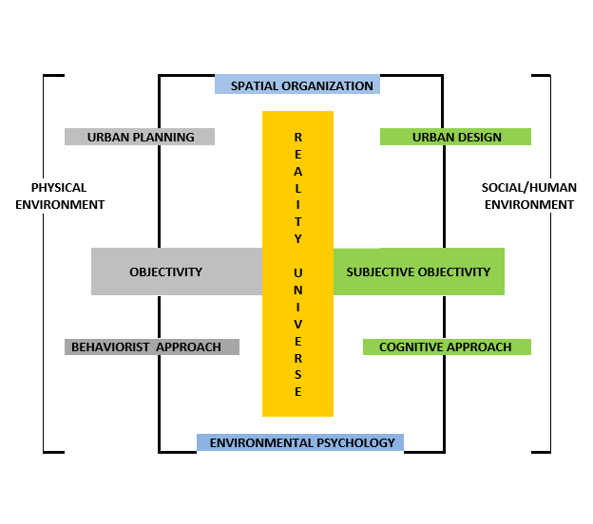
  Figure 3. Reality Universe in the 20th Century. (Işıkpınar, 1995)
  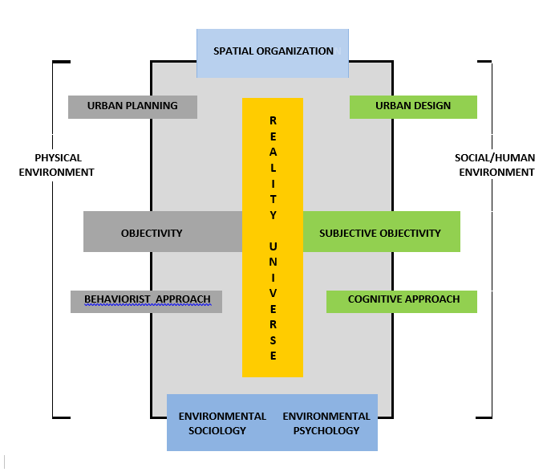
  Figure 4. Reality Universe in 2015
PRACTICAL APPLICATIONS OF THE SUBJECTIVE AND THE OBJECTIVE IN URBAN DESIGN
Implications on Planning : A Case Study
The implications of the theoretical framework to spatial planning exhibited above had been conducted by the first author of this paper in several towns and cities empirically and pragmatically. The study was conducted in European Turkey, Marmara and North-western Anatolia regions of Turkey Period 1990-1995. (Figure 3.) (Işıkpınar, 2011). The study was undertaken within the general framework of the Planning Department of İllerbank (The Municipalities Bank of Turkey, affiliated to the Ministry of Public Works, responsible for financial and technical assistance to municipalities) (İllerbank, 1995).
Basically In all practical applications of collecting data The Eclectic Methodology is essential. In the approach undertaken in this paper, the eclectic approach has been modeled mainly by two approaches : Ecological Psychology and Cognitive Psychology. These approaches have been utilized in the process in conjunction with the urban sociological approach.
The eclectic approach has four phases. So far as objectivity and subjectivity are under question the approach can be analyzed in four phases. The first two phases utilize the behaviorist objective approach basically of sociology and ecological psychology. First of all demographic data for each settlement is collected. In the second phase interviews are conducted with the actors involved in the urban life of the settlement under question. Based on demographic data and interviews, data are collected for the formulation of questionnaires to be administered for the interested parties. In the third phase, work is conducted based on Ecological Psychology. As the investigation tool numerical quotient was formulated named SACQ (Social Activity Constructional Quotient) The findings of S.A.C.Q. value makes a hierarchically nested investigation of cities’ social and economic potentials possible. In the fourth phase, subjective evaluations are attempted. Each setting (space or place) is taken individually one by one whereby the emotional load of the environment is evaluated through environmental psychology and cognitive psychology approaches. Thus a matrix of internal, mental, subconscious preferences is achieved to constitute the eclectic phase of the survey for the assessment of the affordances of the physical settings. (Işıkpınar, Eco)

The Ecological Psychology Methodology : The Objective Data
An approach which would represent and project the external real world objectively was required. Ecological psychology presents such an approach.
Methodology covered the following main points :
• | The demographic data acquired from statistics and interviews were utilized.
• | The basic unit of evaluation was at the parcel scale
• | For each parcel a social activity value dependent on the intensity of the activity on that parcel was determined .
• | A unit value named S.A.C.Q. (social activity constructional quotient) was acquired by dividing social activity values by the number of parcels. [social activity(SA)/parcel(P) = sacq]
• | In parallel with Manning Theory formulated by Parker, which states that a setting ceases to exist when it is not occupied (Barker, 1968; Wicker, 1984 ) the sacq values for unoccupied parcels for any reason, be it barren or deserted, were accepted to be 0.00 (0.00 SA/ P=0.00). The values obtained for the settlements investigated can be followed on Columns 1, 2, 3 in the SACQ Table.
Thus a sheet showing the SACQ values was obtained, which was named the ‘Urbanization Process’, as the sheet acquired indicated the position of urban development in the transitory period. (Figure 4.)
Some of the objectively acquired data are below :
• | Citizens preferences for main city functions,
• | The overall settlement layout potential of the urban environment
• | The demographic potential of the settlement

The Cognitive Psychology Methodology : The Subjective Data
In the Cognitive Psychology Phase each setting (or space and/or place) is taken individually one by one whereby the emotional load of the environment is evaluated through cognitive psychology approaches. Thus a matrix of internal, mental, subconscious preferences is achieved to constitute the eclectic phase of the survey for the assessment of the affordances of the physical settings configuring the urban scene such as the following :
• People’s reactions to the introduction of these new functions,
• People’s reactions to crowdedness and spaciousness (DENSITY),
• The image and identity of the city,
• The shape, layout and other physical characteristics, of public spaces, streets, and other urban elements.
Density values can be seen in the columns 4, 5 ,6 of the Table.

The locations of the towns and cities investigated are given in Figure 5. and the data obtained are given in the Table. below.

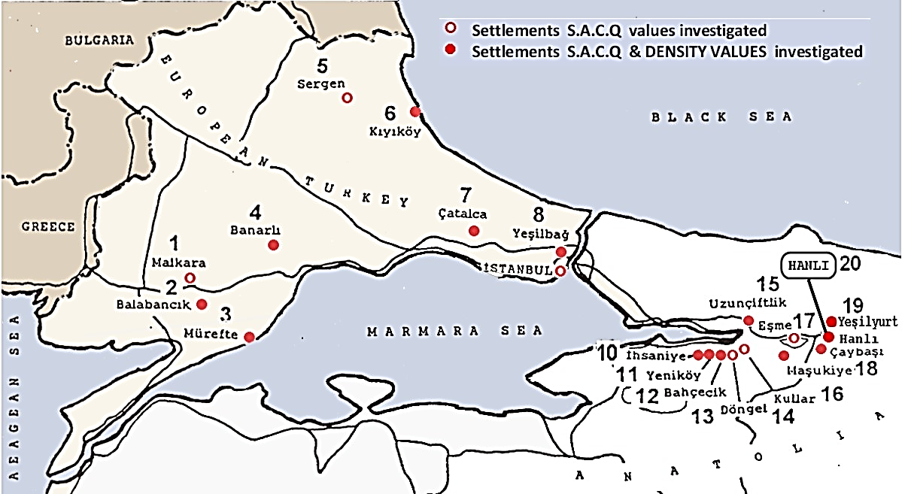
Figure 5. The Settlements Investigated with Objective & Subjective Approaches (Işıkpınar, 1995)

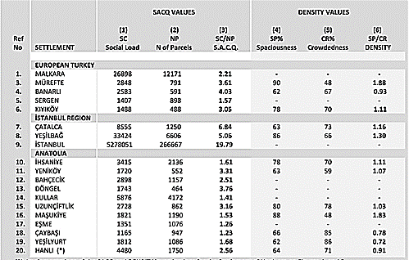
All data obtained in the Period between 1990-1995.
Table. Objective (SACQ) & Subjective (DENSITY) Values of Settlements
Investigated (Işıkpınar, 1995)

A Specific Case Study : Master Plan of the Settlement of Hanlı (Adapazarı City, Sakarya Province, Turkey) (Table, Ref No.20.) (İllerbank, 1999; Işıkpınar, 2011)

Findings of the investigation have been as follows (Figure 6.) :
• | Objective : Implementations of the SACQ VALUES makes possible a linearly projected replica of the layout of the settlement under investigation which reflects the present social and economic potential of the settlement. Thus a basic data sheet is achieved. (Figure 6.1.)
• | Subjective : Implementations of the cognitively acquired DENSITY values of the inhabitants’ preferences are exhibited in (Figure 6.2.)
• | The data acquired from these sheets are superposed with other several sheets relating to the demographic and physical aspects of the settlement, such as historical development, topography, climate. (Figure 6.3.)
• | Finally, abiding by the classical spatial planning principles and utilizing the data thus acquired The Master Plan is achieved : (Figure 6.4.)
Implementations of the findings at the planning phase are demonstrated below :
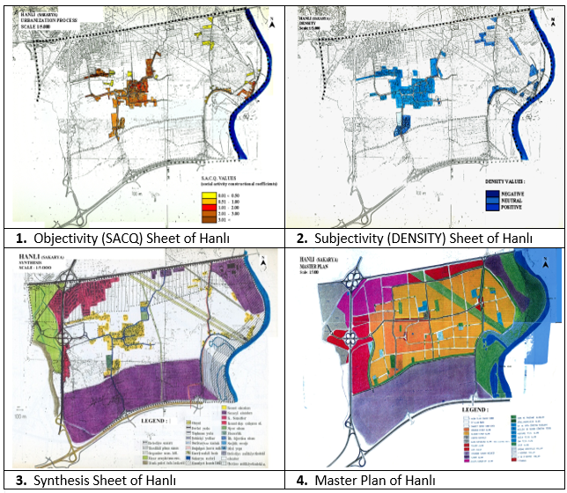
Figure 6. Objective & Subjective Evaluations for the Settlement
of Hanlı (Işıkpınar, 2011)

THE FINAL WORDS
A main issue is on ‘environmental ethics’. As designated in Kant’s Theory of Ethics the success of the universally established maxim is dependent on the success of good will and freedom (Categorical Imperative). (AKARSU, 1987) In the urban scene freedom depends on the establishment of urban dwellers participation. As a human reality the attainment of participation passes through the individual’s self-identification of himself and environmental awareness. Self- identification and a new awareness of the environment are all psychological issues also enhanced by the sociological whole. (Işıkpınar, 2009)

Kuhn accentuates that a change in a paradigm will come about as a result of a ‘crisis’ in a normal science. Under such a condition novel theories have to be explored. ach to the urban should cover both the subjective and the objective, and secondly data objectivity can be handled through subjective approaches, thus the coining of the concept of ‘subjective objectivity’ should be the new paradigmatic approach. (Kuhn, 1982 )

References
Akarsu, B., 1987. Çağdaş Felsefe, Kant'tan Günümüze Felsefe Akımları (Eng. Contemporary Philosophy, Philosophy Movements from Kant to Present) , İkinci Baskı, İnkılâp Kitabevi.
Barker, R.G., 1968 Ecological Psychology: Concepts and methods for studying environment of human behavior, Stanford, CA: Stanford University Press.
Baudrillard. J., 1982. A L'ombre Des Majorités Silencieuses Ou La Fin Du Social, Paris: Editions Danoél/Gunthier.
Boundless, 2015. Sociological Perspectives on Urban Life. Boundless Sociology. Boundless, 21 Jul. 2015. Retrieved 14 Oct. 2015 from https://www.boundless.com/sociology/textbooks/boundless-sociology-textbook/population-and-urbanization-17/urban-life-124/sociological-perspectives-on-urban-life-699-10355/
Conaway, A., 2000. Careers in Environmental Psychology. A Senior Seminar in Psychology (PSY400) Retrieved November 12, 2009 from website: www.ehow.com/about_5032087_careers-environmental-psychology.html.
Crossman, A., 2015. Environmental Sociology - An Overview - About.com, Retrieved from https://www.google.com.tr/search?sourceid=navclient&hl=tr&ie=UTF-8&rlz=1T4GGHP_trTR660TR660&q=a+sub+discipline+within+the+field+of+sociology+that+studies+of+the+interactions+between+the+physical+environment%2C+social+organization%2C+and+social+behavior.&gws_rd=ssl.
Çubuk, M., 1973. Beşeri Yerleşmelerde Mekan Organizasyonu ve Ülkesel Kalkınmayı Bir Mekan Organizasyonu İçinde Yaratmak (Eng. Spatial Organization in Human Settlements and to Create the Development of the Country Within A Spatial Organization , İstanbul State Fine Arts Academy the Faculty of Architecture, İstanbul Devlet Güzel Sanatlar Akademisi Publication: 74, Docent’s Thesis.
Dilthey, W. 1883 Introduction to the Human Sciences, Preface, publ. Princeton University Press.
Feyerabend, P., 1975.Against Method, Outline of an anarchistic theory of knowledge, Retieved on 8 October 2015 from https://www.marxists.org/reference/subject/philosophy/works/ge/feyerabe.htm
Giedion, S., 1963. Space, Time and Architecture, the growth of a new tradition, Fourth Edition, enlarged, Cambridge, Massachusetts.
Hewet, C.,2008. Auguste Comte - High Priest of Positivism - The Great Debate, The Scientific Revolution and Enlightenment, Retrieved from thttp://www.thegreatdebate.org.uk/Comte1.html 2008.
History, 2015. Enlightenment, Retrieved from 2 0ctober 2015 from http://www.history.com/topics/enlightenment.
Işıkpınar, M.E., 2011. Complexity and Transactional Dynamics: 9th Meeting, Self Organizing and Spatial Planning Meeting, AESOP Association of European Schools of Planning and Yildiz Technical University Faculty of Architecture Department of City and Regional Planning, 29-30 April, 2011, İstanbul, Turkey, delivered, proceedings not printed.
Işıkpınar, M.E., 2009. Ecocentrism : Environmental Awareness”. Ecocity 2009 Proceedings, İstanbul,13-15 December 2009, Ecocity Builders, E-Book, pp.622-633.
Işıkpınar, M.E., 1999. “Transformation of Social Reality In Cities and the Restructuring of the Main Social Paradigm”: International Conference Research Community For the Habitat Agenda, Linking Research and Policy For the Sustainability of HumanSettlements, Proceedings, CERFE Group, ss.555-576.
Işıkpınar,E.M., 1995. Çevresel Psikoloji ve Mekan Etkileşimi : Mekan Düzenlemede Psikolojik Boyut Üzerine Yöntemsel Bir Araştırma (Eng. Environmental Psychology and Spatial Interaction : Methodical Research On the Psychological Dimension In Organizing Space), Mimar Sinan University, Faculty of Architecture, Department of City and Regional Planning, İstanbul, Turkey, Ph.D. Thesis.
İllerbank, 1999. Reports on Planning Conducted at İllerbankGeneral Directorate of İllerbank, Ankara: İllerbank Publications.
Kai, C., 2009. Evaluating Architecture: Objective or Subjective, Kai’s Notes on Architecture.
Retrieved from https://gutschow.wordpress.com/2009/05/18/evaluationg-buildings-objective-or-subjective/
Kuhn, T.S., 1982. Bilimsel Devrimlerin Yapısı, Orig. The Structure of Scientific Revolutions, trans. Nilüfer Kuyaş, 2nd ed., Alan Yayıncılık.
Lynch, K. 1975. The Image of the City, Thirteenth Printing, the M.I.T. Press, Massachusetts Institute of Technology.
McCormick, M, 2015. Immanuel Kant, Metaphysics California State University. Retrieved on 17 September 2015 from http://www.iep.utm.edu/kantmeta/.
Rapoport, A., 1977. Human Aspects of Urban Form, 1st Printing, Pergamon Press.
Richards, R., 2001. A New Aesthetic for Environmental Awareness: Chaos Theory, the Beauty of Nature, and Our Broader Humanistic Identity. Journal of Humanistic Psychology 2001 41: 59-95. Retrieved on October 11, 2015 from http://jhp.sagepub.com/cgi/content/abstract/41/2/59
Stanford Encyclopedia of Philosophy, 2005. Hermeneutics, 1st published on 2005,
Retrieved on September 10, 2015 from http://plato.stanford.edu/entries/hermeneutics/.
Takala, Martti, 1997, Environmental Awareness and Human Activity. International Journal of Psychology, 26(5), pp.585-597, Retrieved October 14, 2009 from http://www.informaworld.com/smpp/content~db=all~content=a782387610
Tonkis, Fran; 2005. Spatial Stories : Subjectivity in the city, Space, the City and Social Theory: Social Relations and Urban Forms,: 1st Ed, Polity Press city, P.113.
Mathew , V.G., Environmental Psychology. Retrieved on October 9, 2009 from http://www.psychology4all.com/environmentalpsychology.htm.
Weber, M., 1994. Definition of Sociology, Sociological Writings. Ed. Wolf Heydebrand, published by Continuum.
Wicker, A.W., 1984. An Introduction to Ecological Psychology, Cambridge University Press.

